# Chapter 3 Individual Differences and Emotions,

How Does Who I Am Affect My Performance?

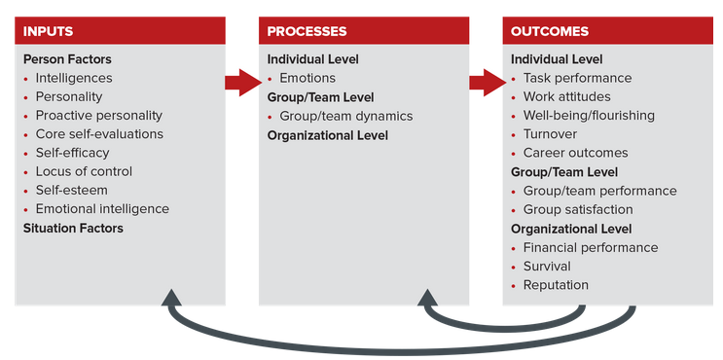

## 3.1 The Differences Matter,

Individual differences (IDs) are the many attributes, such as traits and behaviors, that describe each of us as a person. IDs are a big part of what gives each of us our unique identities, and they are fundamental to the understanding and application of OB. So, what is it that makes us different? Is it our genetics or our environment? The answer is both. And while the way you are raised, along with your experiences and opportunities, indeed helps shape who you are, a large volume of research on twins suggests that genetics matters more. But what is more important at work is recognizing the many attributes that make us unique individuals, regardless of whether they are due to nature or nurture.

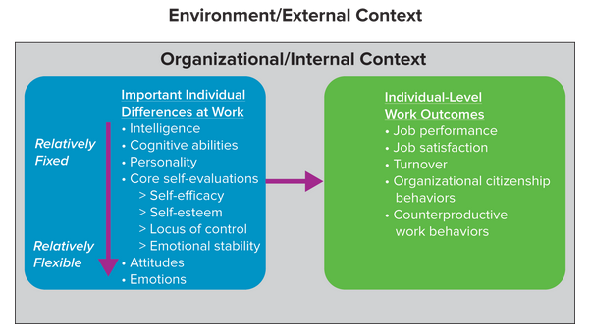

On the left-hand side of Figure 3.2 we arrange individual differences on a continuum. At the top of the continuum are intelligence and cognitive abilities, which are relatively fixed. This means they are stable over time and across situations and are difficult to change. At the bottom are attitudes (which we discussed in Chapter 2) and emotions, which are relatively flexible. Emotions change over time and from situation to situation, and they can be altered more easily. To elaborate, you aren't more or less intelligent at school than you are at work or home, although your emotions commonly change within and between all of these places. Of course both your intelligence and emotions, as well as many other individual characteristics influence the many outcomes included in the right side of Figure 3.2.

The distinction between relatively fixed and flexible individual differences has great practical value. Wise managers know they have little or no impact on fixed IDs. You can’t change an employee’s level of intelligence or remake an employee’s personality. But you can help employees manage their attitudes and emotions. For instance, many effective managers (and their employers) select employees based on positive, job-relevant, but relatively stable IDs. This hiring strategy enables managers to capitalize on the personal strengths that someone brings to a job because these stable strengths affect behavior and performance in most every work situation. Intelligence and analytical abilities, for example, are beneficial in front of customers, in teams with coworkers, and when working alone on a project.

In contrast, managers can have more influence on relatively flexible IDs that influence individual-level work outcomes, like performance and job satisfaction. They can do this by implementing policies that raise employees’ core self-evaluations, attitudes, and emotions. For example, as a manager you’ll likely see better results from assigning work with new products and new markets to employees who are open to experience than to employees with low levels of this attribute. Similarly, you could help build new employees’ confidence about selling to tough customers if you role-model how to do this effectively, give them experience presenting to easy customers first, and provide verbal encouragement before and constructive feedback after.

## 3.2 Intelligences: There Is More to the Story than IQ,

Although experts do not agree on a specific definition, many say intelligence represents an individual’s capacity for constructive thinking, reasoning, and problem solving. Most people think of intelligence in terms of intelligence quotient or IQ, the famous score on tests we often take as children. Thus many people typically view intelligence and IQ as one big attribute of brainpower. However, intelligence, intelligence testing (for IQ), and related research are more complex.

The concept of intelligence has expanded over the years and today is thought of and discussed in terms of general mental abilities. Of course, people are different in terms of such abilities, but this isn’t what is important at work. What is important is to understand intelligence or mental abilities so you can manage people more effectively. Put another way, the reason we highlight intelligence and mental abilities is that they are related to performance at work. This section provides a brief overview of intelligence and mental abilities and then highlights practical implications.

Intelligence Matters … and We Have More Than We Think,

Historically, intelligence was believed to be purely genetic, passed from one generation to another, so you were either born smart or not. Do you agree with this belief? What are the implications of believing that intelligence is a gift of birth? Regardless of your personal views, research has shown that intelligence, like personality, can be altered or modified in a number of ways. Think about it. No matter who you are or where your starting point in education or experience is, if you engage in more constructive thinking, reasoning, and problem solving, you will get better at these skills. You’ll be more intelligent. If you buy this argument, then after reading this book and studying OB you’ll be more intelligent due to the practice in critical thinking and problem solving you’ll gain. Your intellectual development can also be damaged or diminished by environmental factors such as drugs, alcohol, and poor nutrition.

Am I More Intelligent than My Parents?

If you answer yes to this question, research might just support your claim. A steady and significant rise in average intelligence among those in developed countries has been observed over the last 70 years. Why? Experts at an American Psychological Association conference concluded, some combination of better schooling, improved socioeconomic status, healthier nutrition, and a more technologically complex society might account for the gains in IQ scores. So, if you think you’re smarter than your parents and your teachers, despite their saying you don’t know important facts they do, you’re probably right!

Multiple Intelligences (MI),

While many people think of intelligence in general terms, such as IQ, it is more common and more practical to think in terms of multiple intelligences, or an intelligence for something specific. Howard Gardner, a professor at Harvard’s Graduate School of Education, investigated the nature of intelligence for years and summarized his findings in his 1983 book Frames of Mind: The Theory of Multiple Intelligences. The eight different intelligences he identified, listed in Table 3.1, include not only mental abilities but social and physical abilities and skills as well.

Many believe the concept of multiple intelligences has important implications for employee selection, training, and performance. For example, one-size-fits-all training programs often fall short when diversity of intelligences is taken into consideration. When clinical training for undergraduate nursing students was designed to draw on and apply their eight intelligences, for example, they acquired greater proficiency in clinical skills. This type of training also enabled them to utilize and develop their interpersonal intelligence, extremely important for effective patient care.

Near the end of this chapter, you will encounter the concept of emotional intelligence, which managers can apply for employee selection and other purposes. Future breakthroughs in the area of multiple intelligences will attract more OB ­researchers and practicing managers.

Practical Intelligence,

We can draw practical benefits from Gardner’s notion of multiple intelligences. For instance, Yale’s Robert J. Sternberg applied Gardner’s naturalist intelligence to the domain of leadership under the heading practical intelligence. He explains: Practical intelligence is the ability to solve everyday problems by utilizing knowledge gained from experience in order to purposefully adapt to, shape, and select environments. It thus involves changing oneself to suit the environment (adaptation), changing the environment to suit oneself (shaping), or finding a new environment within which to work (selection). One uses these skills to (a) manage oneself, (b) manage others, and (c) manage tasks.

Practical Implications,

Many educators and parents have embraced the idea of multiple intelligences because it helps explain how a child could score poorly on a standard IQ test yet be obviously gifted in other ways such as music, sports, or relationship building. It then follows that we need to help each child develop in his or her own unique way and at his or her own pace. Many people make the same arguments about college students and employees. Of course, everybody has strengths and weaknesses. But what is important as a matter of practice is to identify intelligences relevant to the job, and then to select, place, and develop individuals accordingly. What is your view? Do you see any value in testing for various forms of intelligence at work? Why or why not?

## 3.3 Personality, OB, and My Effectiveness,

Personality is the combination of stable physical, behavioral, and mental characteristics that gives individuals their unique identities. These characteristics or traits, including the way we look, think, act, and feel, are the product of interacting genetic and environmental influences and are stable over time and across situations and cultures. Personality is a person input in the Organizing Framework.

There Is More to Personality Than Liking and Fit,

Like most people, you may often think of personality in terms of whether you like or dislike someone. For instance, if you’re asked to describe your professor for this class you might say: She's great. I love her personality. Or if asked to describe your boss you might say: He’s a difficult individual, he’s unethical, many of his colleagues won’t associate with him, and he is widely disrespected and should be fired. If you are recruiting somebody for a job (or your fraternity or sorority) you might say: I really like his/her personality … I think he/she will fit in great with the rest of us.

Be Precise to Be Effective,

To be effective at managing people you need to be more precise (and scientific) about personality. This challenge has motivated a tremendous amount of research about personality in psychology and in OB. What we need are more specific definitions of what personality is, tools to measure it, and data about the effect it has on important processes and outcomes across all levels of the Organizing Framework.

The Big Five Personality Dimensions,

Defining something as complex as personality is quite a challenge. Fortunately, psychologists and researchers have distilled long lists of qualities and characteristics into the Big Five Personality Dimensions that simplify more complex models of personality. The dimensions are extroversion, agreeableness, conscientiousness, emotional stability, and openness to experience. Table 3.2 details the five personality dimensions. For example, someone scoring high on extroversion will be an extrovert, outgoing, talkative, sociable, and assertive. Someone scoring low on emotional stability will likely be nervous, tense, angry, and worried.

Table 3.2 CHARACTERISTICS OF PERSONS SCORING HIGH ON THE FIVE DIMENSIONS

The Big Five Personality,

Dimensions, Personality Characteristic,

1. Extroversion, Outgoing, talkative, sociable, assertive,

2. Agreeableness , Trusting, good-natured, cooperative, softhearted,

3. Conscientiousness, Dependable, responsible, achievement-oriented, persistent,

4. Emotional stability, Relaxed, secure, unworried,

5. Openness to experience, Intellectual, imaginative, curious, broad-minded,

SOURCE: Adapted from M. R. Barrick and M. K. Mount, Autonomy as a Moderator of the Relationships between the Big Five Personality Dimensions and Job Performance, Journal of Applied Psychology, February 1993, 111–118.

A person’s scores on the Big Five reveal a personality profile as unique as his or her fingerprints. To discover your own Big Five profile, complete Self-Assessment 3.1. In the process you’ll learn there is more to personality than just being likable or fitting in. This Self-Assessment will increase your self-awareness and illustrate some of the concepts just described. Many companies use personality profiles for hiring and promotions, so your profile should provide practical insights.

Proactive Personality,

A proactive personality is an attribute of someone relatively unconstrained by situational forces and who effects environmental change. Proactive people identify opportunities and act on them, show initiative, take action, and persevere until meaningful change occurs. In short, people with proactive personalities are hard-wired to change the status quo. It therefore is no surprise that this particular individual difference has received growing attention from both researchers and managers. Think about it. Companies, and their managers, routinely say they want employees who take initiative and are adaptable. Many argue that today’s hypercompetitive and fast-changing workplace requires such characteristics.

Proactive Managers,

What about your manager? Interesting recent work showed that the ideal scenario is for both you and your manager to be proactive. This results in a better fit and better relationship between the two of you, and it also increases your level of job performance, job satisfaction, and affective commitment. The same study also showed that the worst scenario in terms of performance was low proactivity for both you and your manager, followed by a highly proactive manager and a low proactivity follower. Thus proactivity is a highly valued characteristic in the eyes of employers. And being proactive has direct and indirect benefits for your performance. Given these facts, how proactive do you believe you are? How might you increase your proactivity? To help answer these questions, learn about your own proactivity, and explore the potential benefits for you, complete Self-Assessment 3.2.

Proactivity and Entrepreneurs,

Besides leading to increases in job performance, job satisfaction, and affective commitment (as discussed in Chapter 2), proactive personality is also linked to intentions to be entrepreneurial. This really should not be surprising, but it is helpful to know that scientific OB research substantiates this belief. Building on this, we can say that employees with proactive personalities are more likely to be engaged (again, see Chapter 2) and creative at work.

Successful entrepreneurs often exemplify the proactive personality. Consider Dan Goldie, former professional tennis player and successful financial adviser. Goldie’s youthful passion was tennis, and his talent led him to junior championship titles, a scholarship at Stanford, and a ranking of 27th on the pro tour. Now he considers himself more successful at managing money than he ever was at tennis. Impressive to be sure.

Personality and Performance,

Instead of simply assuming personality affects performance, let’s see what research has to say and how this knowledge can make you more effective. First, and most generally, your personality characteristics are likely to have the greatest influence and effect on performance when you are working in situations that are unstructured and with few rules. This makes sense. You’re more likely to show your true colors (your personality) when the situation is open and lacks constraints.

As for the Big Five, knowledge of these stable personality dimensions can assist in selecting the right people and assigning them responsibilities that will set them up to win.

Conscientiousness has the strongest (most positive) effects on job performance and training performance. Individuals who exhibit traits associated with a strong sense of purpose, obligation, and persistence generally perform better than those who do not. They also tend to have higher job satisfaction. This trait has consistently been shown to be the most influential when it comes to performance at work.

Extroversion is associated with success for managers and salespeople, and more generally for jobs that require social skills. It is also a stronger predictor of job performance than agreeableness, across all professions.

Introverts have been shown to score their extroverted and disagreeable coworkers more harshly than their similarly introverted coworkers. The implication is that introverts focus on interpersonal skills more than extroverts when evaluating coworkers’ performance. How might this affect you in peer evaluations at school and/or work?

Agreeable employees are more likely to stay with their jobs (not quit). They tend to be kind and get along with others, and thus they often have positive relationships and experiences at work.

Openness seems to lead to higher turnover. Open employees are curious and likely to seek out new opportunities, even when they are satisfied with their current jobs. This characteristic seems like a double-edged sword for employers. On the one hand they want open and flexible employees, but these are also the same employees who are likely to quit. How might you deal with this as a manager or the owner of a business?

Emotional stability, along with conscientiousness and agreeableness, is associated with a greater focus on and practice of workplace safety. Imagine you are a manager in a chemical plant. How might you use this knowledge in selecting new employees? In assigning and training existing employees?

Personality Testing at Work,

Personality testing is a commonly used tool for making decisions about hiring, training, and promotion. Current estimates are that approximately 76 percent of organizations with more than 100 employees now use some sort of pre- or post-hiring assessment, including personality tests, spending more than $500 million annually on such services. A few of the major reasons organizations use such tests are that they:

Reduce time and cost of recruiting and hiring.

Reduce biases in the interview process.

Increase the pool of candidates (because such tests can be administered electronically and remotely).

Complement candidate information found in résumés and interviews.

Personality tests, in particular, are more widely used at the management level than at the entry level (80 percent and 59 percent of the time, respectively). However, despite this widespread use, many experts argue that the typical personality test is not a valid predictor of job performance. One reason might be that many test takers don’t describe themselves accurately but instead try to guess what answers the employer is looking for.

Wise managers learn about personality and the tools used to measure it before investing in and/or utilizing the data they yield. Table 3.4 provides some insights.

There Is No Ideal Employee Personality,

Given the complexity of today’s work environments, the diversity of today’s workforce, and recent research evidence, the quest for an ideal employee personality profile is sheer folly. Just as one shoe does not fit all people, one personality profile does not fit all job situations. Good managers take the time to get to know each employee’s unique combination of personality traits, abilities, and potential and then create a productive and satisfying person–job fit. In other words, a contingency approach to managing people is best (recall the discussion of contingency in Chapter 1).

## 3.4 Core Self-Evaluations: How My Efficacy, Esteem, Locus, and Stability Affect My Performance,

So far we’ve discussed both general and specific, or narrow, individual differences. A narrow perspective on personality enables us to describe individuals more precisely than general personality traits do. For example, it is more insightful to say that Steve Vai, a phenomenal progressive rock guitarist and a favorite of one of your authors, has incredible musical intelligence than to say that he is intelligent.

Steve Vai studied with rock guitarist and teacher Joe Satriani and attended the renowned Berklee College of Music in Boston. Early in his career Vai transcribed music and played for the legendary musician Frank Zappa. He is widely considered a virtuoso and would be expected to score very highly on musical intelligence. What other intelligences might influence his guitar playing, composing, and song writing?

A broader perspective, in contrast, allows us to more effectively predict behavior. The reason is that broader concepts provide a more comprehensive and practical account of an individual’s behavior. This view suggests that part of Vai’s guitar-playing prowess likely is due to other factors beyond his musical intelligence.

There is no clear answer as to which of these approaches is more accurate. However, researchers have identified a broad or general personality trait with significant relationships to a host of individual-level work outcomes included in Figure 3.2 and the Organizing Framework. This trait is called core self-evaluations (CSEs). Core self-evaluations (CSEs) represent a broad personality trait made up of four narrow and positive individual traits: (1) generalized self-efficacy, (2) self-esteem, (3) locus of control, and (4) emotional stability. (See Figure 3.3.) People with high core self-evaluations see themselves as capable and effective. This section discusses the component traits and highlights research and managerial implications for each.

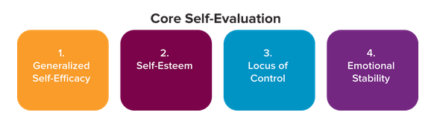

Why should you care about CSEs? CSEs have desirable effects on many outcomes in the Organizing Framework, such as increased job performance, job and life satisfaction, motivation, organizational citizenship behaviors, and better adjustment to international assignments. Better still, CSEs can be developed and improved. They also have been studied in the executive suite. A study showed that CEOs with high core self-evaluations had a positive influence on their organization’s drive to take risks, innovate, and seek new opportunities. This effect was especially strong in dynamic business environments.

Self-Efficacy, I Can Do That ,

Have you noticed that those who are confident about their ability tend to succeed, while those who are preoccupied with failing tend to fail? At the heart of such performance differences is self-efficacy. Self-efficacy is a person’s belief about his or her chances of successfully accomplishing a specific task.

Mechanisms of Self-Efficacy,

A detailed model of self-efficacy is shown in Figure 3.4. To apply this model, imagine you have been told to prepare and deliver a 10-minute talk to an OB class of 50 students on how to build self-efficacy. How confident are you that you can complete this task? Part of your self-efficacy calculation is to evaluate the interaction between person and situation factors described in the Organizing Framework.

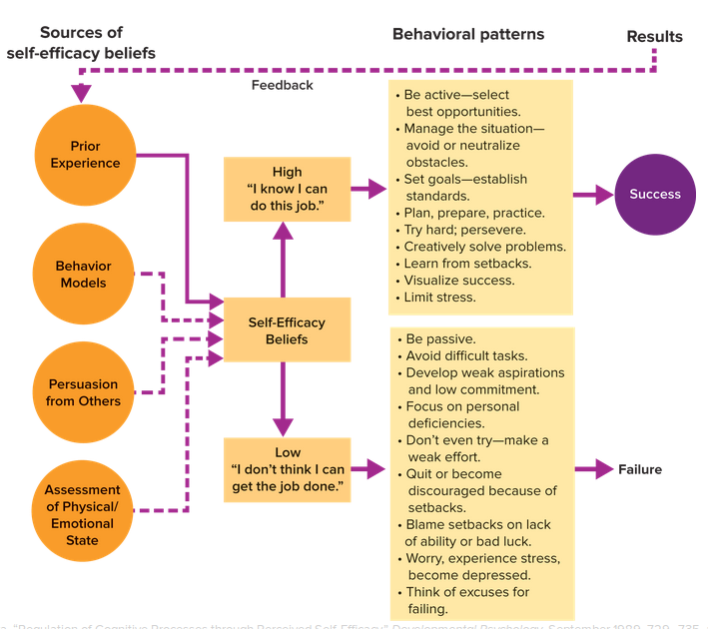

Managerial Implications,

Self-efficacy has been extensively studied in the workplace. The data support a number of recommendations. As a general rule, managers are encouraged to nurture self-efficacy in themselves and others because it is related to improved job performance and job satisfaction (both are important individual-level outcomes). Table 3.5 provides a number of specific means for building self-efficacy. Nearly all are explained in detail in other chapters of this book.

Self-Esteem, Look in the Mirror ,

Self-esteem is your general belief about your own self-worth. Personal achievements and praise tend to bolster self-esteem, while prolonged unemployment and destructive feedback tend to erode it. Researchers measure self-esteem by having people indicate their agreement with positive and negative statements about themselves. An example of a positive statement is, I feel I am a person of worth, the equal of other people. An example of a negative statement is, I feel I do not have much to be proud of. Those who agree with the positive statements and disagree with the negative statements have high self-esteem. They see themselves as worthwhile, capable, and accepted. People with low self-esteem view themselves in negative terms. They do not feel good about themselves and are hampered by self-doubts.

Nationality, Life Span, and Gender,

Some have argued that self-esteem is largely a Western or even an American concept. To address this allegation, researchers surveyed more than 13,000 students from 31 countries. They found that self-esteem and life satisfaction were moderately related on a global basis. However, the relationship was stronger in individualistic cultures (United States, Canada, New Zealand, and the Netherlands) than in collectivist cultures (Korea, Kenya, and Japan). The likely reason is that individualistic cultures socialize people to focus more on themselves and value their own attributes and contributions, compared to people in collectivist cultures who are socialized to fit into the community and to do their duty (value the group more than oneself).

Some notable practical recommendations:

Nationality, Global managers should de-emphasize self-­esteem when doing business in collectivist ( we ) cultures, as opposed to emphasizing it in individualistic ( me ) cultures.

Life span, You can expect your self-esteem to remain fairly stable over the course of your life, especially after age 30.

Gender, Self-esteem differences between men and women are small at best.

Can Self-Esteem Be Improved?

Case for: Researchers have found one method especially effective for improving self-esteem. Low self-­esteem can be raised more by having the person think of desirable characteristics possessed rather than of undesirable characteristics from which he or she is free.

Locus of Control: Who’s Responsible, Me or External Factors?

Locus of control is a relatively stable personality characteristic that describes how much personal responsibility we take for our behavior and its consequences. We tend to attribute the causes of our behavior primarily to either ourselves or environmental factors. (Recall our discussion of the person–­situation distinction in Chapter 1.) Locus of control thus has two fundamental forms, internal and external.

Internal Locus of Control,

People who believe they control the events and consequences that affect their lives are said to possess an internal locus of control. Such people, called internals, tend to attribute positive outcomes to their own abilities and negative outcomes to their personal shortcomings. Many entrepreneurs eventually succeed because their internal locus of control helps them overcome setbacks and disappointments. They see themselves as masters of their own fate and not as simply lucky. Those who willingly take high-stakes jobs in the face of adversity (such as pulling a company back from scandal or bankruptcy) likely also have a high internal locus of control. Although Yahoo! continued to struggle in 2016 and will likely be sold, CEO Marissa Mayer undoubtedly has a high internal locus. This partly explains her willingness to take on the challenge of turning the company around in the face of great difficulties and criticism.

External Locus of Control,

In contrast, those who believe their performance is the product of circumstances beyond their immediate control­possess an external locus of control and tend to attribute outcomes to environmental causes, such as luck or fate. An external would attribute a passing grade on an exam to something external like an easy test and attribute a failing grade to an unfair test or distractions at work.

Locus in the Workplace,

The outcomes of internals and externals differ widely at work.

Internals,

Display greater work motivation.

Have stronger expectations that effort leads to performance.

Exhibit higher performance on tasks that require learning or problem solving, when performance leads to valued rewards.

Derive more job satisfaction from performance.

Externals,

Demonstrate less motivation for performance when offered valued rewards.

Earn lower salaries and smaller salary increases.

Tend to be more anxious.

Emotional Stability,

As described in our discussion of the Big Five and in Table 3.2, individuals with high levels of emotional stability tend to be relaxed, secure, unworried, and less likely to experience negative emotions under pressure. In contrast, if you have low levels of emotional stability, you are prone to anxiety and tend to view the world negatively. How is this knowledge useful at work? Employees with high levels of emotional stability have been found to have higher job performance and to perform more organizational citizenship behaviors. Recall that organizational citizenship behaviors (OCBs) are actions that go above and beyond your job responsibilities to benefit the organization. Emotionally stable employees also exhibit fewer counterproductive work behaviors (CWBs), actions that undermine their own or others’ work. Both OCBs and CWBs were discussed in Chapter 2 and are individual-level outcomes illustrated in Figure 3.2 and the Organizing Framework. For an illustration of the way emotional stability affects an individual’s professional and personal life, see the OB in Action box about Alphabet (Google) Chief Financial Officer Ruth Porat.

Is More Always Better?

Like having more self-esteem, having greater emotional stability is not always better. Researchers found curvilinear, or inverted-U, relationships between emotional stability and outcomes. This suggests that as your emotional stability increases, so too will your job performance and organizational citizenship behaviors, but only to a point.

Effect on organizational citizenship behaviors. As emotional stability continues to increase, OCBs decline, likely because you focus your attention on the task at hand and not on your coworkers. Typically, that’s a good thing. However, at a certain level emotional stability becomes problematic if you begin obsessing over details and lose sight of the larger objectives and those with whom you work.

Effect on counterproductive work behaviors. Research found that emotional stability buffered or protected participants against stressors at work (trouble with their supervisors, unfair policies, and too much work). Thus they were less bothered and less likely to act out by committing CWBs. But there was a tipping point when the stress became too much and emotional stability could not prevent counterproductive behaviors.

What is the lesson for you? Emotional stability is an asset for many types of jobs, but it will take you only so far.

Is the Whole of CSE Greater than Its Parts?

Clearly a team outperforms any individual playing alone. Even the greatest player ever would have no chance against an entire team. The five greatest players ever, playing individually, still have no chance against an entire team. Individually they would never score! Thus the sum of their solo efforts would be zero.

How Can I Use CSEs?

Especially in a managerial role, you can use your knowledge of CSEs in many practical ways, such as:

Employee selection. It is more efficient to select employees using CSEs as one broad personality characteristic rather than using its four component traits. Employers can determine the link between one characteristic (CSE) and performance in a particular job, rather than having to determine the relationships between each of the four components parts and performance. This is one relationship versus four. Doing so also enables managers and employers to take advantage of the many beneficial outcomes described above.

Training. The training potential of CSEs is limited because most of its components are trait-like or relatively fixed (self-esteem, locus of control, and emotional stability). That said, self-efficacy is more flexible than the other three components and can be enhanced as explained above. (Figure 3.4 is an excellent how to guide.)

## 3.5 The Value of Being Emotionally Intelligent,

What Is Emotional Intelligence?

Emotional intelligence is the ability to monitor your own emotions and those of others, to discriminate among them, and to use this information to guide your thinking and actions. Referred to by some as EI (used in this book) and by others as EQ, emotional intelligence is a mixture of personality and emotions and has four key components (see also Table 3.6):

1. Self-awareness
2. Self-management
3. Social awareness
4. Relationship management

The first two dimensions constitute personal competence and the second two feed into social competence. Recall the discussion earlier in the chapter of inter- and intra-personal intelligences described by Gardner. EI builds on this work.

Benefits of EI,

What Research Tells Us

EI has been linked to better social relationships, well-being, and satisfaction across all ages and contexts, including work. For instance, store managers’ EI was shown to foster greater team cohesiveness (covered in Chapter 8) among sales associates, and this in turn boosted sales. EI has also been linked with creativity, helping employees manage their emotions amid the challenges of the creative process in order to stay on task and remain in the creative space. EI further enables individuals to apply positive emotions to their work, improving their creative outcomes.



## 3.6 Understand Emotions to Influence Performance,

Emotions, We All Have Them, but What Are They?

Emotions are complex, relatively brief responses aimed at a particular target, such as a person, information, experience, or event. They also change psychological and/or physiological states. Researchers distinguish between felt and displayed emotions. For example, if your boss informs you that you’ve been passed over for a promotion, you might feel disappointed and/or angry (felt emotion). You might keep your feelings to yourself or you might begin to cry. Both reactions are instances of displayed emotions. It’s just that in the first case you are choosing not to show emotion, which means your display is no emotion. Your display can affect the outcomes, in this case your manager’s reactions. Taxi drivers, waiters, and hairdressers all received higher tips when they were trained to manage what they felt and the way they displayed these feelings.

Emotions as Positive or Negative Reactions to Goal Achievement

You’ll notice from the definition that you can think of emotions, whether positive, negative, or mixed, in terms of your goals.

Positive. If your goal is to do well in school and you graduate on time and with honors, you are likely to experience positive emotions such as joy, gratitude, pride, satisfaction, contentment, and relief. These emotions are positive because they are congruent (or consistent) with your goal.

Negative. Negative emotions are triggered by frustration and failure to meet goals. They are said to be goal incongruent. Common negative emotions are anger, fright, anxiety, guilt, shame, sadness, envy, jealousy, and disgust. Which of these are you likely to experience if you fail the final exam in a required course? Failing would be incongruent with your goal of graduating on time with a good GPA. Typically, the more important the goal, the more intense the emotion.

Mixed. Meeting or failing to meet our goals can also generate mixed emotions. Say you receive a well-earned promotion that brings positives like more responsibility and higher pay, but only if you relocate to another state, which you don’t want to do.

Besides Positive and Negative, There’s Past vs. Future

The negative–positive distinction matters, you’re happy, you’re sad. However, another characteristic of emotions can be especially useful for managers. Assume you’re a manager in a company that just downsized 15 percent of its employees. This is stressful for all those who lost their jobs, but let’s focus on two fictitious employees who survived the cuts, Shelby and Jennifer. Both feel negatively about the job cuts, but in different ways.

Shelby: Her dominant emotion is anger. People are typically angry about things that happened (or didn’t happen) in the past. This means that anger is a backward-looking or retrospective emotion.

Jennifer: Her dominant emotion is fear. People are typically fearful of things that might happen in the future. Fear is thus a forward-looking or prospective emotion.

Practical implications for managers. Knowing these emotions tells you that Shelby is likely most concerned with something that happened in the past, such as the way decisions were made about whom to terminate. She may think the process was unfair and caused a number of her favorite colleagues to be let go. As for Jennifer, knowing she is dominated by fear tells you that it is uncertainty about the future, perhaps her job might be cut next, that concerns her most. As their manager, you can use this more specific knowledge of Shelby’s and Jennifer’s emotions to guide your own ­actions. The following Take-Away Application builds on this scenario.

How Can I Manage My Negative Emotions at Work?

Theoretically, to manage your emotions at work you could simply translate your felt emotions into displayed ­emotions, unfiltered. Besides being unrealistic, however, this would be disastrous. Organizations have emotion display norms, or rules that dictate which types of emotions are expected and appropriate for their members to show. But what can you do when, as is inevitable, sometimes you feel negative emotions at work? The OB in Action box describes the costs and benefits of displaying anger at work.

Anger isn’t the only negative emotion. Table 3.7 provides guidance on a variety of negative emotions and how to deal with them. As you study the table, think of your own experiences and reactions and how the recommendations could have helped you handle them.